Q1. Find the sum of 5 numbers

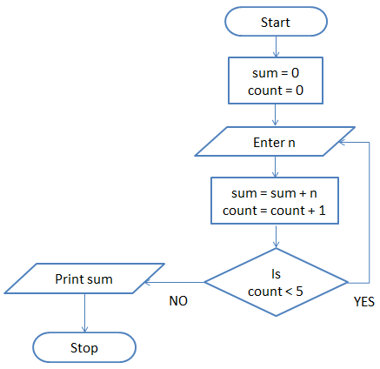

## Q2. Print Hello World 10 times

## flowchart - exercise

## Q3. Find the sum of the numbers in each set.

## https://dyclassroom.com/image/topic/flowchart/flowchart-ex2-q1.png

**Draw flowchart to find the largest among three different numbers entered by user**

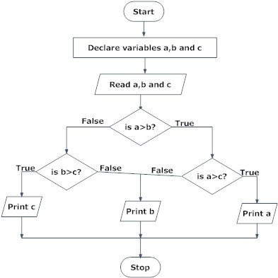

**Draw a flowchart to add two numbers entered by user**

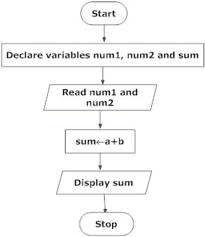

***Flowchart for calculate factorial value of a number:***

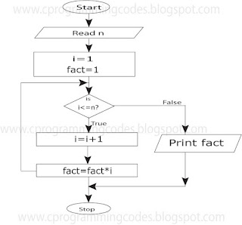

**Draw a flowchart to find the Fibonacci series till term≤1000.**

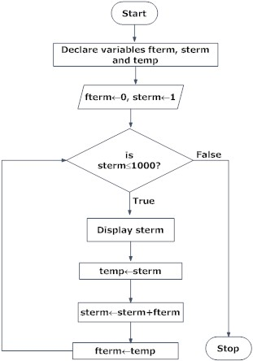

# Flowchart to Swap Two Integer Numbers with and without third variable

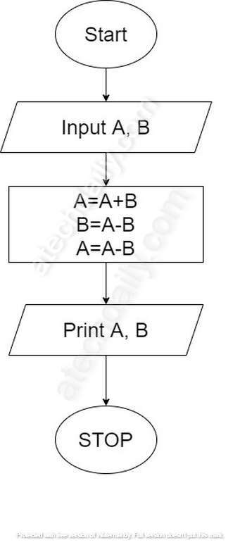

## Flowchart for Swapping two numbers using third variable:

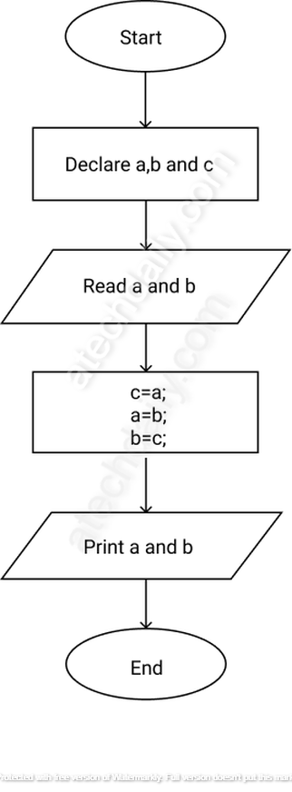

.

## FLOW CHART EXAMPLE 1

*The flowchart is a mean of visually presenting the flow of data through an information processing system, the operations performed within the system and the sequence in which they are performed.*

***Required:  
(a) Draw and briefly explain five symbols commonly used in a flowchart.  
(b) Identify the advantages of using flowcharts.***

## FLOW CHART EXAMPLE 1 SOLUTION

[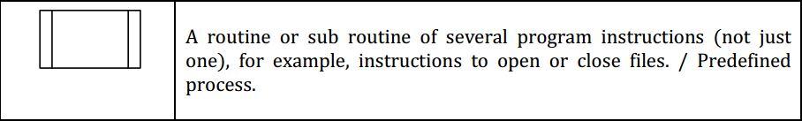](http://auditor101.com/wp-content/uploads/2017/10/A-routine-or-sub-routine-of-several-program-instructions-flowchart.jpg)[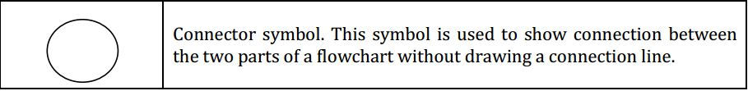](http://auditor101.com/wp-content/uploads/2017/10/Connector-symbol-flowchart.jpg)[](http://auditor101.com/wp-content/uploads/2017/10/Decision-or-condition-symbol-flowchart.jpg)[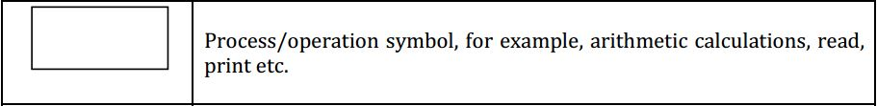](http://auditor101.com/wp-content/uploads/2017/10/Process-operation-flowchart-symbol-for-example-arithmetic-calculations-read-print-etc.jpg)[](http://auditor101.com/wp-content/uploads/2017/10/Start-or-end-symbol.-A-flow-chart-has-one-start-and-one-end-symbol..jpg)

# ADVANTAGES OF USING FLOWCHARTS ARE AS FOLLOWS:

## (I) COMMUNICATION:

Flowcharts facilitate in communicating the logic of a system to all concerned.

## (II) PROPER DOCUMENTATION:

Program flowcharts serve as a good program documentation, which is needed for various purposes.

## (III) EFFICIENT CODING:

The flowcharts act as a guide or blueprint during the systems analysis and program development phase.

## (IV) PROPER DEBUGGING:

The flowchart helps in debugging process.

## (V) EFFICIENT PROGRAM MAINTENANCE:

The maintenance of operating program becomes easy with the help of flowchart, thereby enhancing the programmer’s efficiency.

## FLOW CHART EXAMPLE 2

*Auditor Forum has launched a promotion for its credit card customers. According to the promotion, the customers will receive a gift voucher worth $500 with their monthly bill if they spend $15,000 more than their last month spending and their last month bill is not less than $10,000.*

***Draw a flow chart showing the above process.***

## FLOW CHART EXAMPLE 2 SOLUTION

[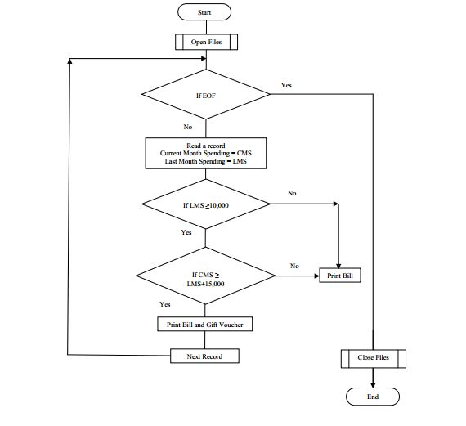](http://auditor101.com/wp-content/uploads/2017/10/flowchart.jpg)

## FLOW CHART EXAMPLE 3

*Auditor Forum allows its customers to access their blood test reports through Internet. At the time of payment, the system creates a unique user ID and password which is printed on the payment receipt. The customer is allowed to log on to Auditor Forum’s website on or after the specified date, to access the report. After logging on to the website the customer is required to input his email address after which the system automatically sends the test report to that email address.*

*After sending the email, the system automatically signs off the customer and displays the message: “Your report has been sent to your email address.”*

*If the customer tries to log on before the report receiving date, the system displays the message:*

*“Your report would be available on the date specified on your payment receipt.”*

*The user ID and password is valid only for fifteen days after the date on which the report becomes available.*

***Required:  
Draw a program flowchart to depict the above process from customer sign in to automatic sign off.***

## FLOW CHART EXAMPLE 3 SOLUTION

[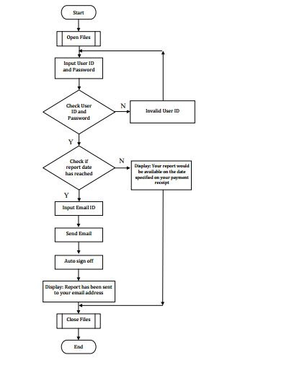](http://auditor101.com/wp-content/uploads/2017/10/flowchart-example.jpg)

## FLOW CHART EXAMPLE 4

*The ATM machines of Auditor Forum Bank contain biometric security features besides conventional PIN control. The customers of Auditor Forum Bank have a choice either to use Card + PIN or Card + Biometric option. Customers of other banks can also withdraw cash from AFB’s ATM; however, they can only use Card + PIN option. A customer’s card is captured by the machine after three consecutive unsuccessful attempts.*

***Required:  
Prepare a program flowchart showing the process of cash withdrawal from AFB’s ATM. Assume that transactions other than cash withdrawals are not allowed.***

## FLOW CHART EXAMPLE 4 SOLUTION

[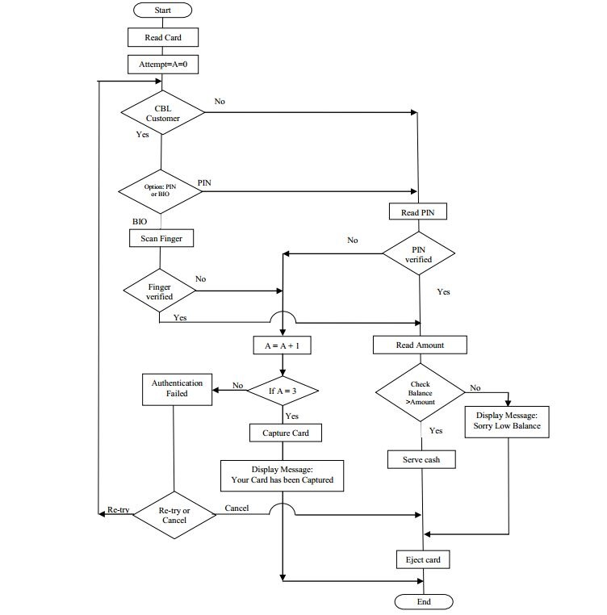](http://auditor101.com/wp-content/uploads/2017/10/flowchart-practice-question-answer.jpg)

## FLOW CHART EXAMPLE 5

*Auditor Forum Limited intends to develop a computer program for the purpose of calculating annual performance bonus for its employees. There are two types of employees viz., permanent and contractual. All the employees have been classified into three categories A, B and C. Managerial staff is placed in category A whereas non-managerial staff are placed in either category B or category C.*

*Employees in category A, contractual employees and employees whose service period is less than nine months are not eligible for the award of bonus. On a scaled score of 1 to 100, the amount of bonus for the eligible employees is determined as follows:*

|  |  |
| --- | --- |
| SCALED SCORE | NO. OF BASIC SALARIES |
| 80 and above | 2.0 |
| 65 – 79 | 1.5 |
| 50 – 64 | 1 |
| Less than 50 | 0.0 |

***Prepare a program flowchart showing the process of calculation of bonus.***

## FLOW CHART EXAMPLE 5 SOLUTION

[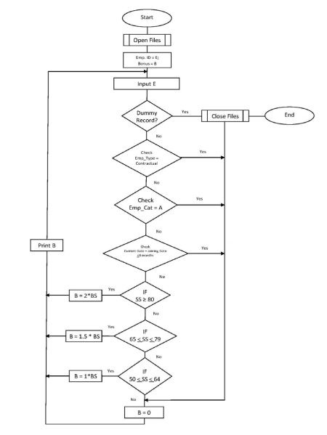](http://auditor101.com/wp-content/uploads/2017/10/flow-chart-example.jpg)